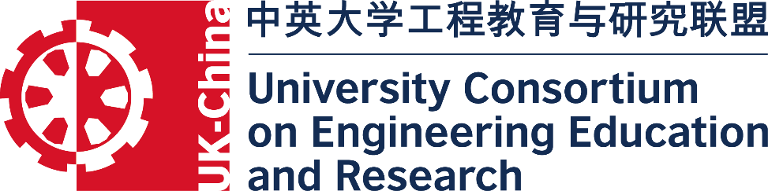

Future Engineers’ Leadership & Innovation Academy: building UK-China teams to support both countries’ manufacturing ambitions

October, 2017 - Beijing, China

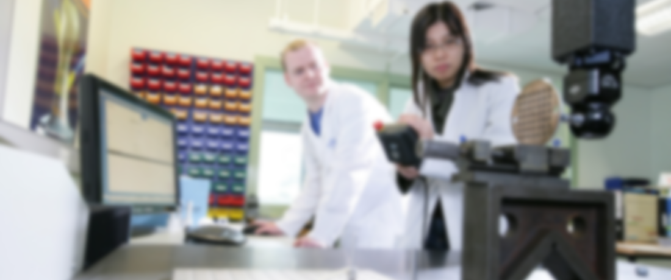

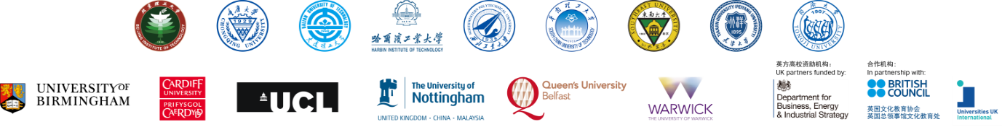
Future Engineers’ Leadership & Innovation Academy
By the end of this programme you will:
- Develop increased leadership skills.
- Gain a high level of confidence to enable you to embrace future engineering challenges.
- Gain practical tips and strategies on how to get the best from people.
- Develop practical transnational communication skills.
- Examine tools for converting ideas into business.
- Discuss the latest technology.

Engineering innovation and leadership are essential to support the manufacturing ambitions of the UK and China. This Future Engineers’ Leadership and Innovation Academy will develop creative, technical, transnational communication, and leadership skills for the next generation of engineers, innovators and entrepreneurs.
The academy builds on the successful Mini-MBA programme developed by the William J Clinton Leadership Institute at Queen’s University Belfast and will be delivered at the Beijing Institute of Technology, Beijing, China. The Academy will promote and encourage transnational team building, communication and the recognition of local culture through lectures, mixed nationality team based projects and tours.
What will you get from the programme?
- Practical leadership skills and strategies for creative thinking.
- Advanced awareness of personal styles and people/project management skills.
- Up to date technical awareness in relevant areas.
- Tools for converting ideas into successful businesses.

What makes this programme special?
This highly interactive programme uses a blend of self-directed reading, class based activity, case studies and practical learning activities to enhance its participants’ skills in core areas of leadership, technical engineering and in an international context.

How long is the programme?
The duration is 2 weeks and is composed of 7, 1-day modules and one, 3-day module. It concludes with a showcase event.

What Language will be used?
All courses are taught in English. Students are encouraged to practice Chinese during their stay in Beijing with other students and local residents.
Timetable (9:00 to 17:00)
Module 1: Leadership and Strategy
Module 2: People, Performance and Project Management
Module 3: Design Engineering
Module 4: Energy Systems
Module 5: Autonomous Systems
Weekend: Cultural Tours
Module 6: Unmanned Aerial or Electric Vehicles (3 days)
Module 7: Finance Essentials
Module 8: Project Marketing and Sales
Assessed showcase event

Who is the programme for?
This programme is for: Engineers from any discipline wanting to become more effective at developing solutions to future global challenges.

Who can apply?
The Academy is open to PhD students studying engineering at any of the partner institutions. Each institution will have the opportunity to select students to compete for 24-30 fully funded* places. Each selected student will have accommodation, food tuition fees and cultural tours paid for. UK students will, in addition, have their travel paid for.

How to get more information:
Visit our website for the latest information: http://go.qub.ac.uk/future-engineers

